Verbal Reasoning

Venn Diagram

Direction sense

Coding-Decoding

Blood Relation

Data Sufficiency

Alpha-Numeric

syllogism

Statement and conclusion

Analogy

Seating arrangemet

Logical sequence of words

<li class="point"><a href="http://127.0.0.1:5501/Project/Coding&Decoding.html">Coding-Decoding</a></li>

                        <li class="point"><a href="http://127.0.0.1:5501/Project/VennDiagram.html">Venn Diagram</a></li>

                        <li class="point"><a href="http://127.0.0.1:5501/Project/BloodRelation.html">Blood Relation</a></li>

                        <li class="point"><a href="http://127.0.0.1:5501/Project/DirectionSense.html">Direction Sense</a></li>

                        <li class="point"><a href="http://127.0.0.1:5501/Project/DataSufficiency.html">Data Sufficiency</a></li>

                        <li class="point"><a href="http://127.0.0.1:5501/Project/AlphaNumeric.html">Alpha-Numeric</a></li>

                        <li class="point"><a href="http://127.0.0.1:5501/Project/Syllogism.html">Syllogism</a></li>

                        <li class="point"><a href="http://127.0.0.1:5501/Project/StatementConclusion.html">Statement-Conclusion</a></li>

                        <li class="point"><a href="http://127.0.0.1:5501/Project/Analogy.html">Analogy</a></li>

                        <li class="point"><a href="http://127.0.0.1:5501/Project/SeatingArrangement.html">Seating Arrangement</a></li>

                        <li class="point"><a href="http://127.0.0.1:5501/Project/LogicalSequenceofWords.html">Logical Sequence of Words

Venn Diagram

Venn Diagram

A Venn Diagram is a representation method for all possible relations that can exist between a given group of elements in a single figure.

**Sample Example on Venn Diagram**

Ex:- Relation between Earth, Sea and sun

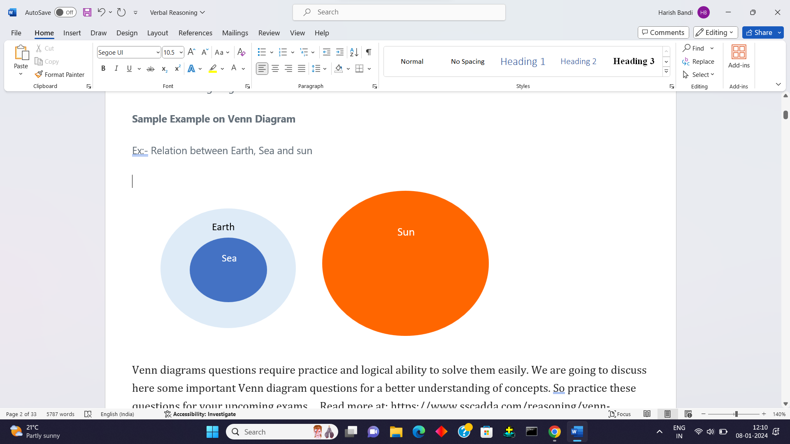

Venn diagrams questions require practice and logical ability to solve them easily. We are going to discuss here some important Venn diagram questions for a better understanding of concepts. So practice these questions for your upcoming exams....

Q.1) Which of the following Venn- diagram correctly illustrates the relation ship among the classes : Tennis fans, Cricket players, Students

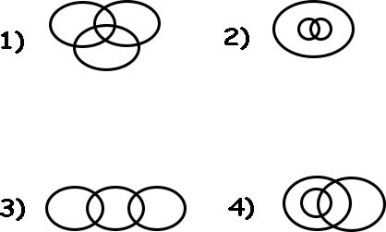

|  |  |
| --- | --- |
|  |  |
|  |  |

[Answer & Explanation](javascript:showans('8595','Logical%20Venn%20Diagram'))**Answer:** A) 1  
  
**Explanation:**

Some Students can be Cricket players. Some Cricket players can be Tennis fans. Some Students can be Tennis fans. So, the given items are partly related to each other.

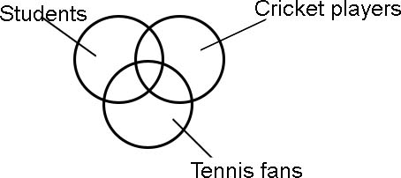

**Q.2)**

Which of the following Venn- diagram correctly illustrates the relation ship among the classes  :  Carrot, Food, Vegetables

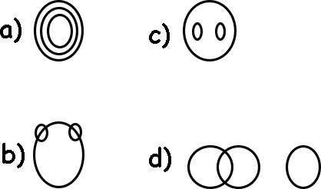

Answer: a

Q.3) Which of the following diagrams indicates the best relation between Factory, Product and Machinery ?

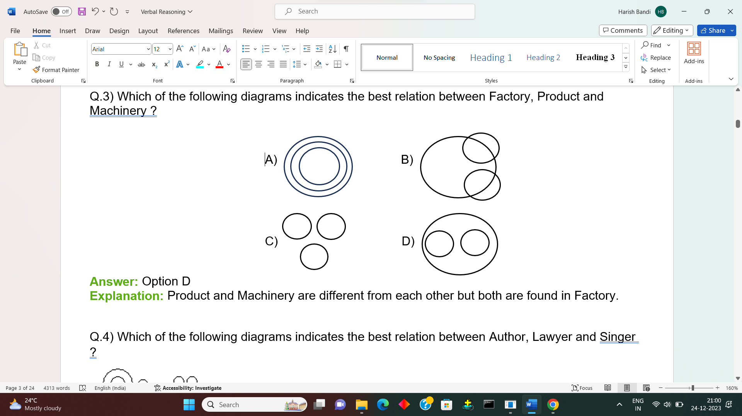

**Answer:** Option D

**Explanation:** Product and Machinery are different from each other but both are found in Factory.

Q.4) Which of the following diagrams indicates the best relation between Author, Lawyer and Singer ?

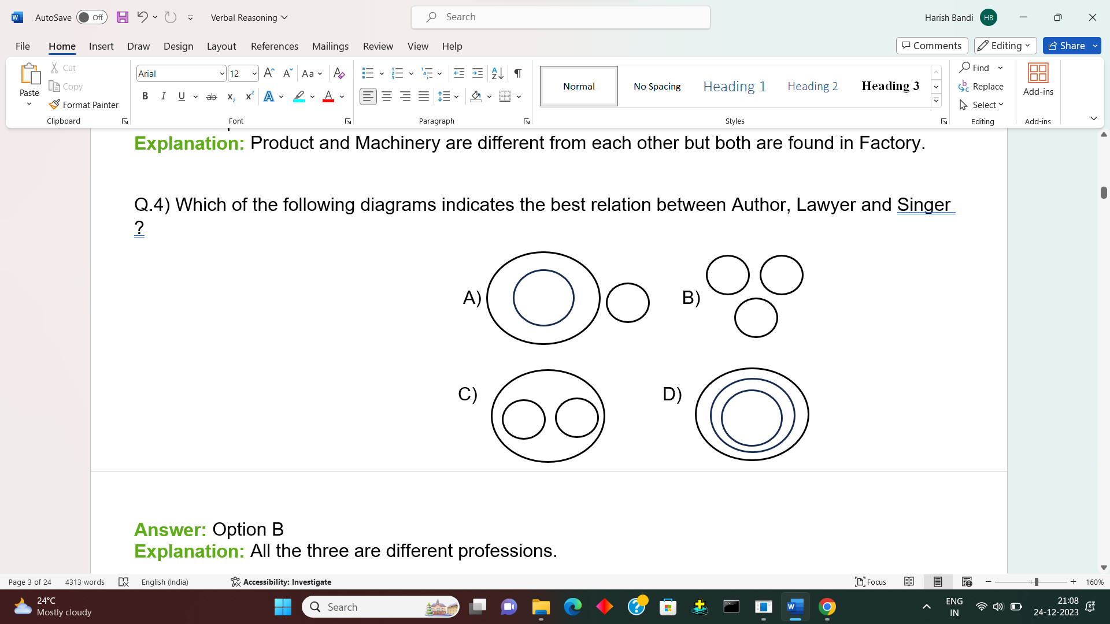

**Answer:** Option B

**Explanation:** All the three are different professions.

Q.5) Which of the following diagrams indicates the best relation between India, Haryana and World ?



**Answer:** Option D

**Explanation:**

Haryana is in India and India is in the World.

Q.6) Which of the following diagrams indicates the best relation between Pigeon, Bird and Dog ?

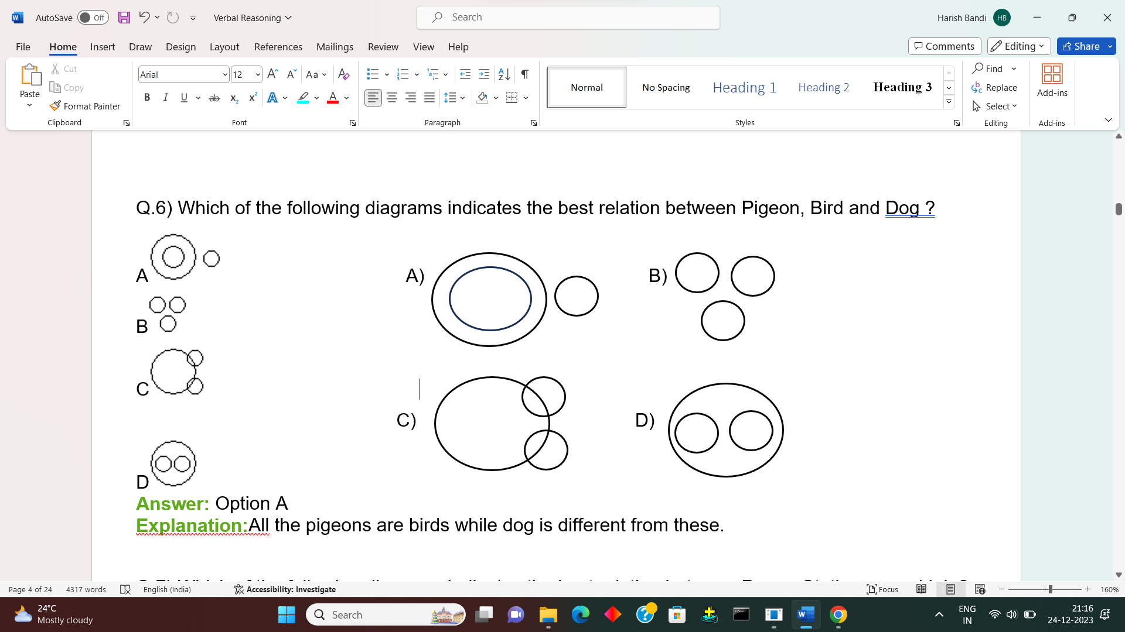

**Answer:** Option A

**Explanation:** All the pigeons are birds while dog is different from these.

Q.7) Which of the following diagrams indicates the best relation between Paper, Stationery and Ink ?

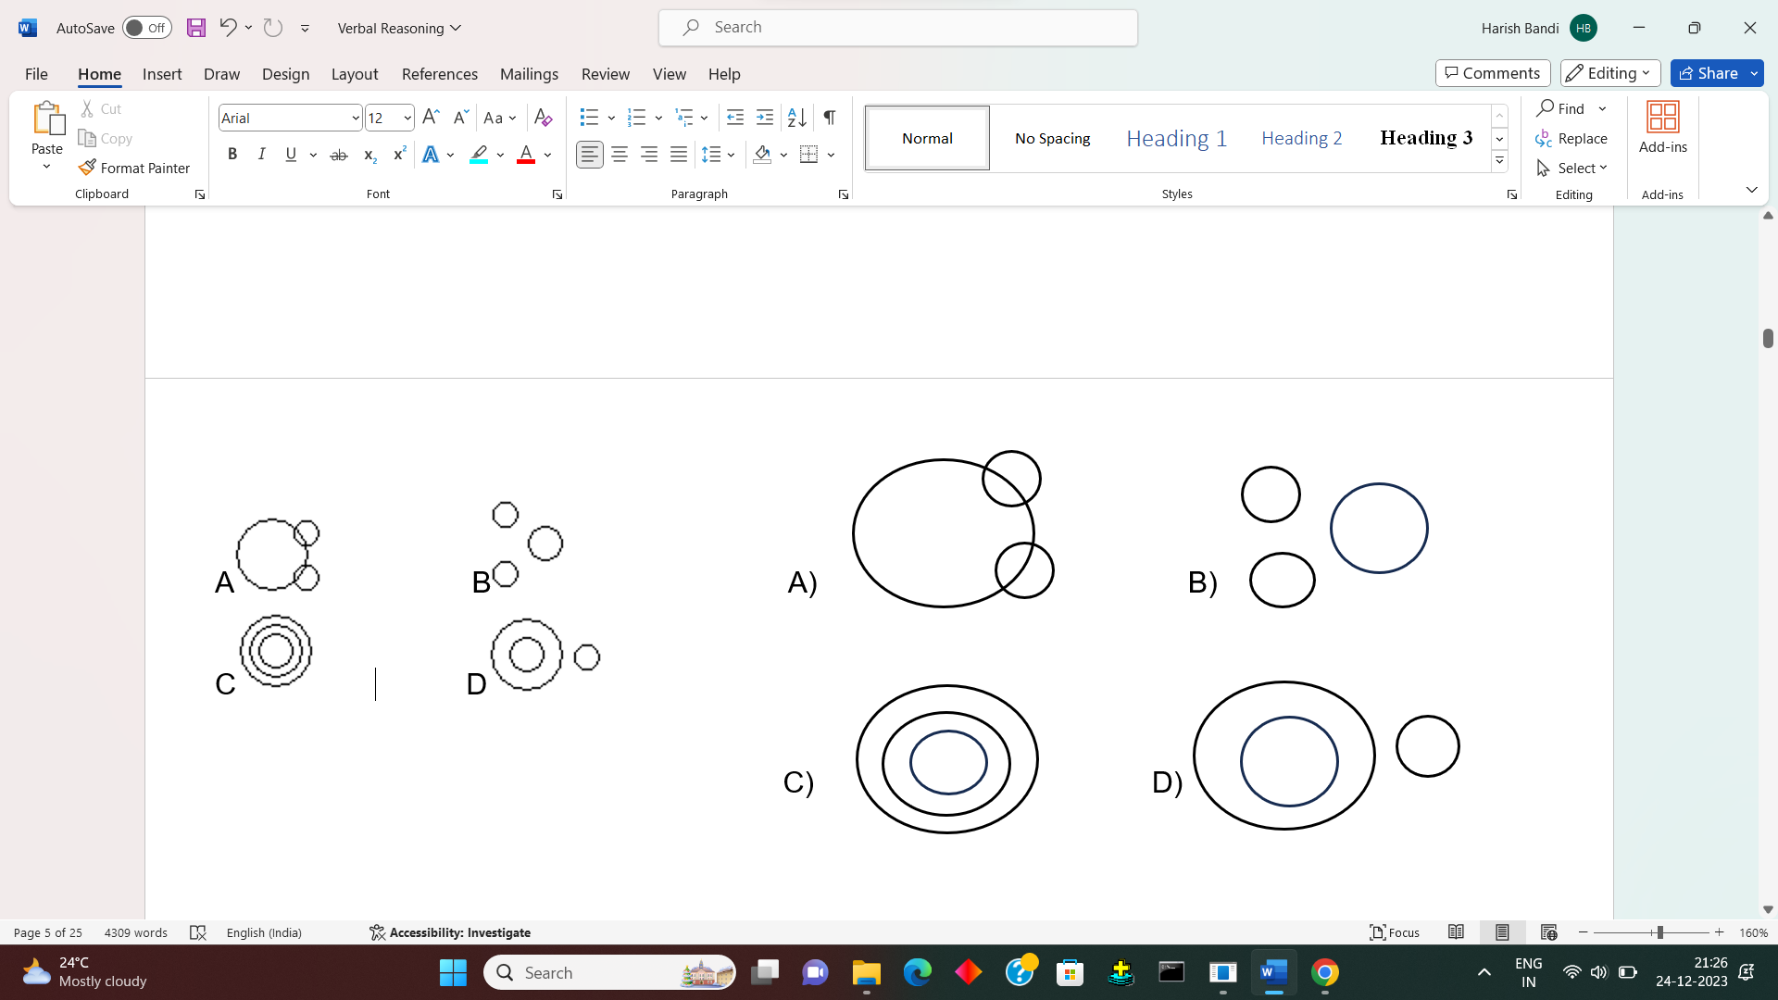

**Answer:** Option A

**Explanation:** Paper and Ink are different from one another but both these belong to stationery.

Q.8) Which of the following diagrams indicates the best relation between Football, Player and Field ?

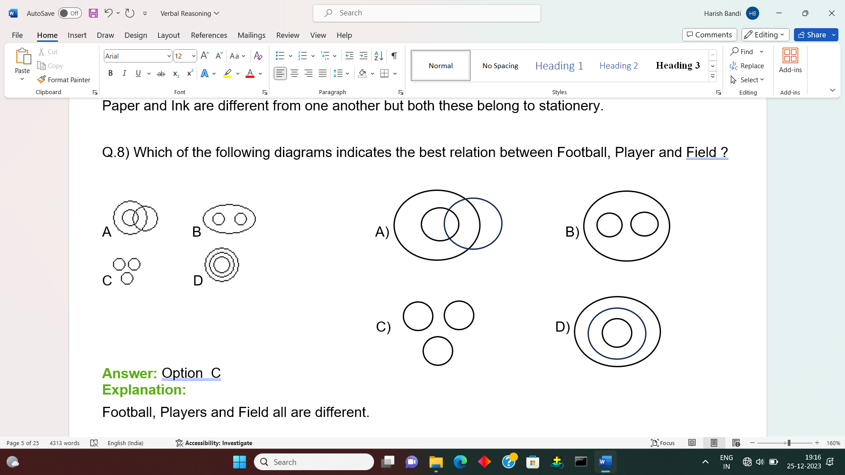

**Answer:** Option C

**Explanation:**

Football, Players and Field all are different.

Q.9) Which of the following diagrams indicates the best relation between Professors, Doctors and Men?

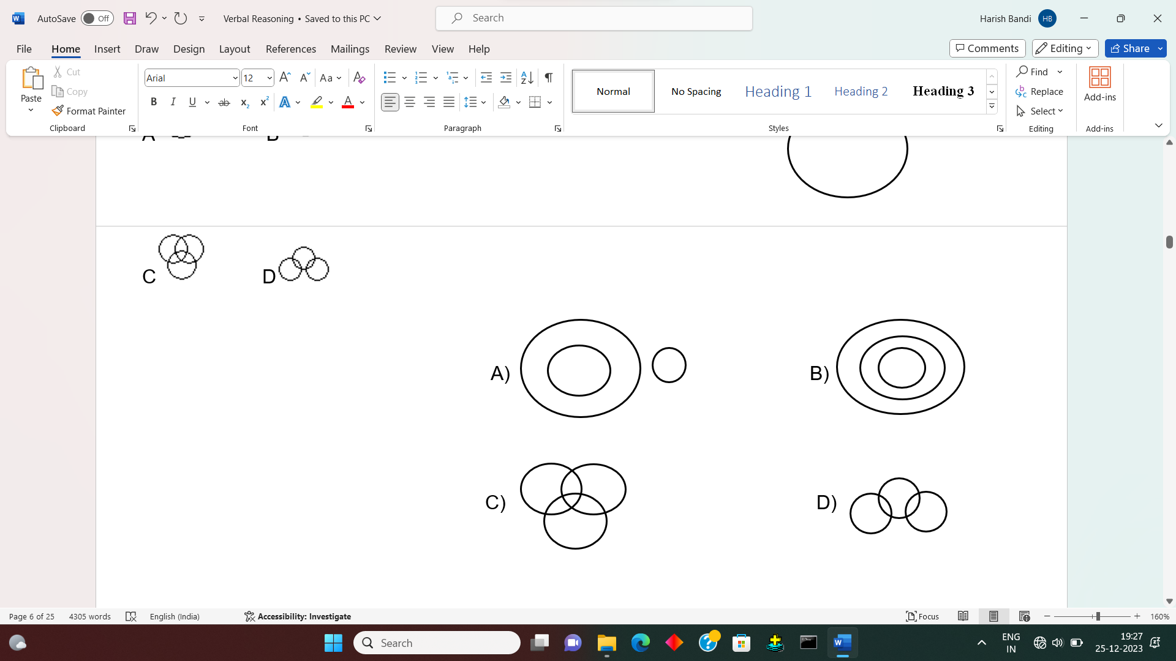

**Answer:** Option C

**Explanation:**

Some doctors may be professors and vice-versa.

Some professors may be men and vice-versa.

Some doctors may be men and vice-versa.

Some doctors may be men and professors as well.

Q.10) Which of the following diagrams indicates the best relation between dogs, pet animals and animals?

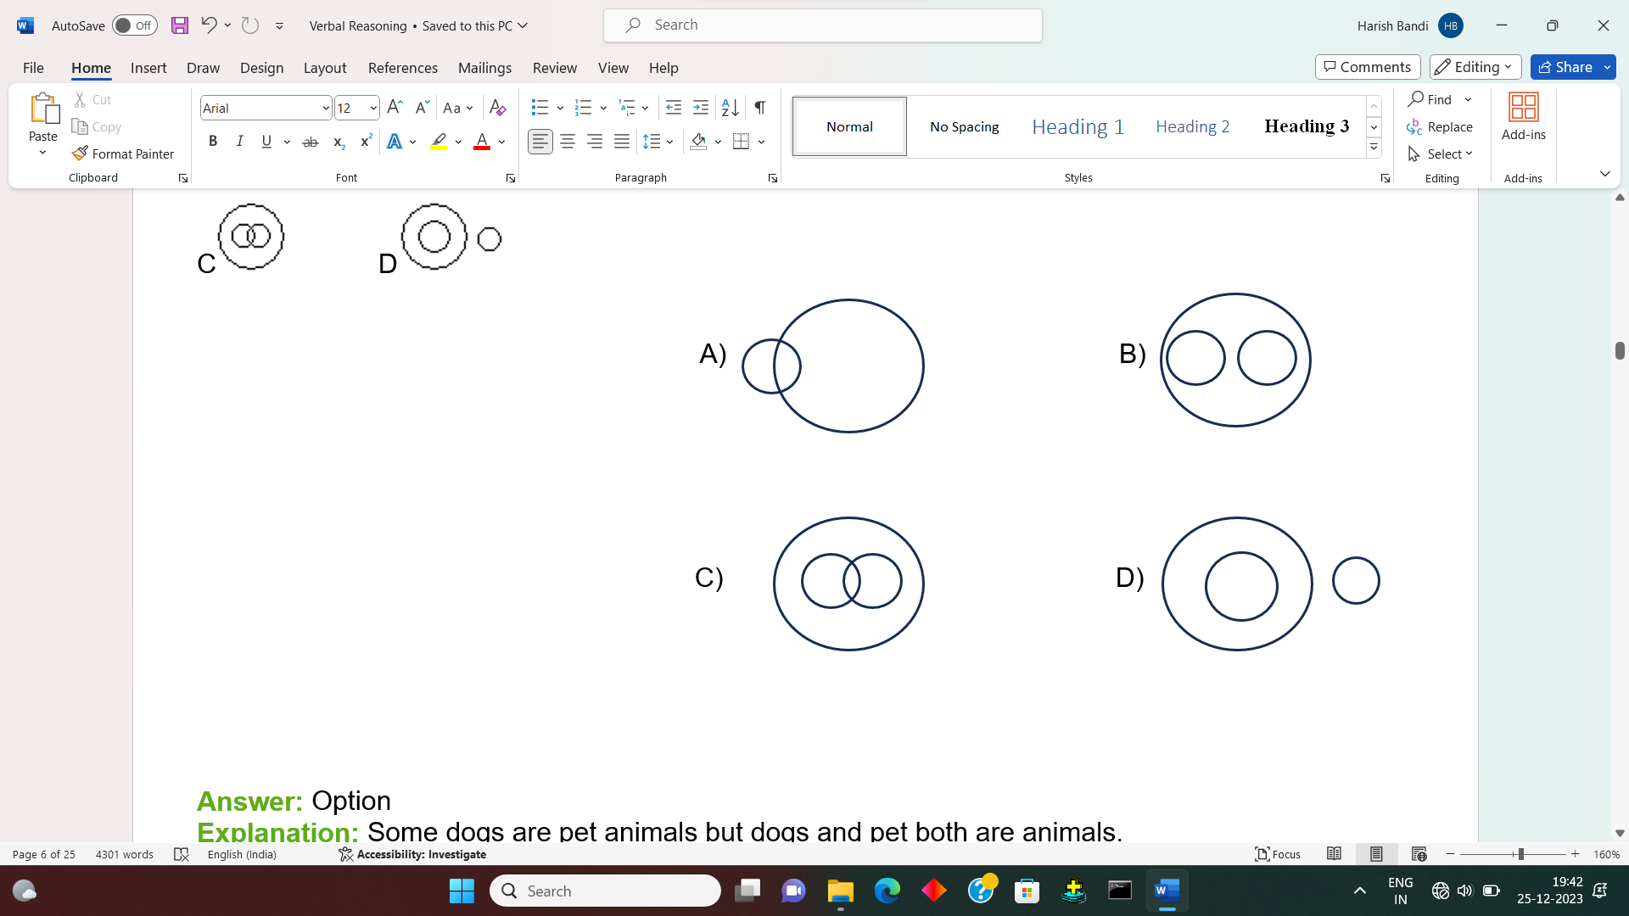

**Answer:** Option C

**Explanation:** Some dogs are pet animals but dogs and pet both are animals.

Coding-Decoding

Coding is a part of the logical reasoning section used to encrypt words, numbers in specific patterns or codes using particular rules and regulations. Decoding is the process that is used to decrypt the patterns into original forms from the given forms.

**Types of Coding-Decoding With Examples**

### A) Letter Coding:Letter Coding is a type in which the letters are replaced with other letters

Example: In certain language PROSE is coded as PPOQE. How will LIGHT coded?

Solution: PROSE:PPOQE from this every second alternative letter as changed to 2nd previous letter So, LIGHT=LGGFT

Letter Coding is a type in which the letters are replaced with other letters.

### B)Number Coding: In the Number Coding we will have to observe and guess the hidden code of two or more sets of numbers. Once the parent code is known, the candidate will have to use this code to generate other numbers.

Example: If “AOUSE” is coded as 35842, and LEMOC is coded as 12659, then what would be the code for AELEC?

Solution: Values From ‘AOUSE’ and ‘LEMOC’ : A=3, E=2, L=1, C=9 Therefore AELEC=32129

C) Substitution Coding : In substitution coding, it assigns particular objects to code names. Then a question is asked to solve the answer in the same pattern. Example: See in practice questions Que.3

### D) Mixed Letter Coding:In this type of question, three or four complete messages are provided in the coded language, and the code for the particular word is asked. To analyze such codes, and if any two messages bearing the common word, are picked. The common code word will be that word. Example: See in practice questions Que.4

### E) Mixed Number Coding: In this mixed number-coding question, three or four complete messages are given in the coded language, and the code number for a particular word is asked.Example: See in practice questions Que.5

### 

Q.1) In a certain code, ‘PEAK’ is written as ‘3512’ and ‘DINE’ is written as ‘6895’. How is KIND written in that code?

2397 2896 2986 2596

Sol: Values From ‘PEAK’ and ‘DINE’ : K=2, I=8, N=9, D=6 Therefore KIND=2896

Q.2) If SENSATIONAL can be written as 12314567348, how will STATION be written in that code

1457626 1545673 1546268 1654275

Sol: Values From ‘SENSATIONAL’ : S=1, T=5, A=4, T=5, I=6, 0=7, N=3 Therefore STATION=1545673

Q.3) If 'white' is called 'red', and 'red' is called 'blue', 'blue' is called 'green', 'green' is called 'yellow', 'yellow' is called 'black', and what is the colour of blood?

Explanation: As we know, the blood is red. So if you observe the above question, it is mentioned that white is called red and red is called blue. So blood is red by using the substitution method, the answer would be blue.

Q.4) In the code language,

1) 'Ha ka bow' means How are you 2) 'ka te ma' means where are they 3) 'se re tho' means good and bad

What does ‘are’ stand for?

Explanation: If you observe the question, it is mentioned that both the 1st and 2nd statements are repeated. So the common word in both these statements is KA. The rest of each word is different. So, "are" stands for ka.

So, according to mixed letter coding, "are" stands for "ka".

Q.5) Q) If 'the monster hunter' is coded as 324,and 'will be the' is coded as 476, and 'they are in' is coded as 158. Which digit represents the?

Explanation: If you observe the question in two statements, the is repeated, and in both the two statements, the only repeated letter is 4. So, as per mixed number coding, the exact code for "the" is "4".

Q.6) If the given letters are represented by the numeral below them,

RTSUVABCDE:8520679134, Then 408927=?

EURSBA ESRBSA EURBSA ESRBAS

Sol: Values From ‘RTSUVABCDE’ : 4=E, 0=U, 8=R, 9=B, 2=S, 7=A Therefore 408927= EURBSA

Q.7) If B=2, BAG=10, then BOX=?

41 52 67 89

Sol: BAG=10 (it is summation of alphabets of B, A, G), so BOX=2+15+24=41.

1. In certain language PROSE is coded as PPOQE. How will LIGHT coded?

LIGFT LGGHT LLGFE LGGFT

Sol: PROSE: PPOQE from this every second alternative letter as changed to 2nd previous letter So, LIGHT=LGGFT

Blood Relation

Blood Relations is the most studied topic of Logical Reasoning and is one of the few topics which has found its importance in almost every entrance exam.

Any relation in the world which either by birth or by marriage is called a Blood Relation.

Ex: Any relation by birth will be mother, father, son, daughter, etc. and any relation by marriage will be father-in-law, mother-in-law, etc.

From Below will get to know various blood Relations

|  |  |
| --- | --- |
| **Type of Relationship** | **Terminology in Use** |
| Mother’s or Father’s son | Myself/Brother |
| Mother’s or Father’s daughter | Myself/Sister |
| Mother’s or Father’s brother | Uncle |
| Mother’s or Father’s sister | Aunt |
| Mother’s or Father’s father | Grandfather |
| Mother’s or Father’s mother | Grandmother |
| Son’s wife | Daughter-in-law |
| Daughter’s husband | Son-in-law |
| Husband’s or wife’s sister | Sister-in-law |
| Husband’s or wife’s brother | Brother-in-law |
| Brother’s son | Nephew |
| Brother’s daughter | Niece |
| Uncle or aunt’s son or daughter | Cousin |
| Sister’s husband | Brother-in-law |
| Brother’s wife | Sister-in-law |
| Grandson’s or Granddaughter’s daughter | Great-granddaughter |

1. A man pointing to a photograph says, 'The lady in the photograph is my nephew's maternal grandmother." How is the lady in the photograph related to the man's sister who has no other sister ?

|  |  |
| --- | --- |
| A) Cousin | B) Sister-in-law |
| C) Mother | D) Mother-in-law |

[Answer & Explanation](javascript:showans('2858','Blood%20Relations'))**Answer:** C) Mother  
  
**Explanation:**

Clearly, the lady is the grandmother of man's sister's son i.e.. the mother of the mother of man's sister's son

i.e., the mother of man's sister. So, the lady is man's mother.

1. Pointing to a woman, a man said, "Her father is the only son of my father." How is the man related to the woman?

|  |  |
| --- | --- |
| A) Father | B) Brother |
| C) Uncle | D) Brother-in-law |

[Answer & Explanation](javascript:showans('18388','Blood%20Relations'))**Answer:** B) Brother  
  
**Explanation:**

The man said, "Her father is the only son of my father."

Then the woman's father and the man's is the same

=> The woman and the man are brother and sisters.

Hence, the man is the brother of the woman

1. Introducing a man to her husband , a woman said "His brother's father is the only son of my grandfather". How is the woman related to this man?

|  |  |
| --- | --- |
| A) Mother | B) Aunt |
| C) Sister | D) Aunt |

[Answer & Explanation](javascript:showans('10228','Blood%20Relations'))**Answer:** C) Sister  
  
**Explanation:**

Only son of woman's grandfather - woman's father;  Man's brother's father - Man's father

So, man's father is woman's father i.e woman is the man's sister.

1. A is father of C and D is son of B. E is brother of A. If C is sister of D, how is B related to E ?

|  |  |
| --- | --- |
| A) Daughter | B) Brother |
| C) Husband | D) Sister-in-law |

[Answer & Explanation](javascript:showans('4143','Blood%20Relations'))**Answer:** D) Sister-in-law  
  
**Explanation:**

A is father of C and C is sister of D. So, A is father of D.

But D is son of B. So, B is the mother of D and wife of K Also. E is the brother of A So, B is the sister-in-law of E.

Q.5) A is the brother of B. B is the brother of C. D is the father of A. Based on these three statements, which of the following statements cannot be definitely true ?

|  |  |
| --- | --- |
| A) B is the brother of A. | B) B is the son of D. |
| C) A is the brother of C. | D) C is the brother of A. |

[Answer & Explanation](javascript:showans('3570','Blood%20Relations'))**Answer:** D) C is the brother of A.  
  
**Explanation:**

A is the brother of B and B is the brother of C. So, C may be the brother or sister of A.

Direction Sense

The questions based on directions require the candidates to identify the direction of an individual or shadow from a set of statements. Some important points are given which can help to understand and solve the related question easily.

Some points you need to know before solving direction sense problems

* There are only four primary directions: north, south, east and west.
* North-East, North-West, South-East, and South-West are the four cardinal directions.
* If a man stands facing east at sunrise, his shadow will be cast towards the west.
* The shadow of an item is always in the east during sunset.
* If a guy stands facing North at daybreak, his shadow will be to his left, and at sunset, it will be to his right .
* The sun’s beams are vertically downward at 12:00 noon, therefore there will be no shadow.

The direction and distance reasoning questions, as the name implies, includes two types of questions i.e.:

1. Direction Sense Test: The questions based on directions require the candidates to identify the direction of an individual or shadow from a set of statements
2. Distance Related questions: While solving the distance related question, one must be thorough with the **Pythagorean Theorem** to be able to solve most of the questions. The Pythagorean Theorem is used to calculate the shortest path travel, the minimum distance between two points

Q.1) A man walks 5 km toward south and then turns to the right. After walking 3 km he turns to the left and walks 4 km. And then he goes back 10 km straight. Now in which direction is he from the starting place ?

|  |  |
| --- | --- |
| A) South-East | B) North-West |
| C) South | D) West |

[Answer & Explanation](javascript:showans('11377','Direction%20Sense%20Test'))**Answer:** B) North-West  
  
**Explanation:**

From the given directions, now he is 1km in the North-West direction.

2) Amit started walking positioning his back towards the sun. After some time, he turned left, then turned right and towards the left again. In which direction is he going now?

|  |  |
| --- | --- |
| A) North or South | B) North or West |
| C) East or West | D) South or West |

EXPLANATION:

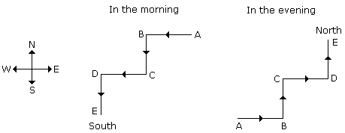

3) A horse is facing north. It turns 90 degrees in the clockwise direction, then 180 degrees in the anti-clockwise and then another 90 degrees in the same direction. Which direction is the horse facing now?

|  |  |
| --- | --- |
| A) East | B) South |
| C) Southwest | D) Southeast |

[Answer & Explanation](javascript:showans('10174','Direction%20Sense%20Test'))**Answer:** B) South  
  
**Explanation:**

Starting from the initial point facing north, the horse turns 90 degrees clockwise, which means it turns towards East. Similarly, the other directions can be considered and written as : EWS Thus, the direction it is facing now is South.

1. Iam facing south. I turn right and walk 20 m. Then I turn right again and walk 10m. Then I turn left and walk 10m and then turning right walk 20m. Then I turn right again and walk 60m. In which direction am I from the starting point?

|  |  |
| --- | --- |
| A) North | B) North-West |
| C) North-East | D) East |

[Answer & Explanation](javascript:showans('9101','Direction%20Sense%20Test'))**Answer:** C) North-East  
  
**Explanation:**  
The movements of the person are from A to F, as shown in Fig. Clearly, the final position is F which is to the North-east of the starting point A

1. A man walks 20 m towards north, then he turns right and walks 3 m, then turns left and walks 4 m and from there he walks 4 m towards east. How far and in which direction is he from his initial position?

|  |  |
| --- | --- |
| A) 25 m east | B) 25 m north-east |
| C) 20 m north | D) 24 m north |

**Answer:** B) 25 m north-east

7 m

N

**H Y**

4 m

W

4 m

E

3 m

24 m

S

20m

**G intial position**

(GY) 2= (HG)2 + (HY)2

(GY) 2= 242 + 72

GY=25

Therefore, 25 m north-east he is from initial position

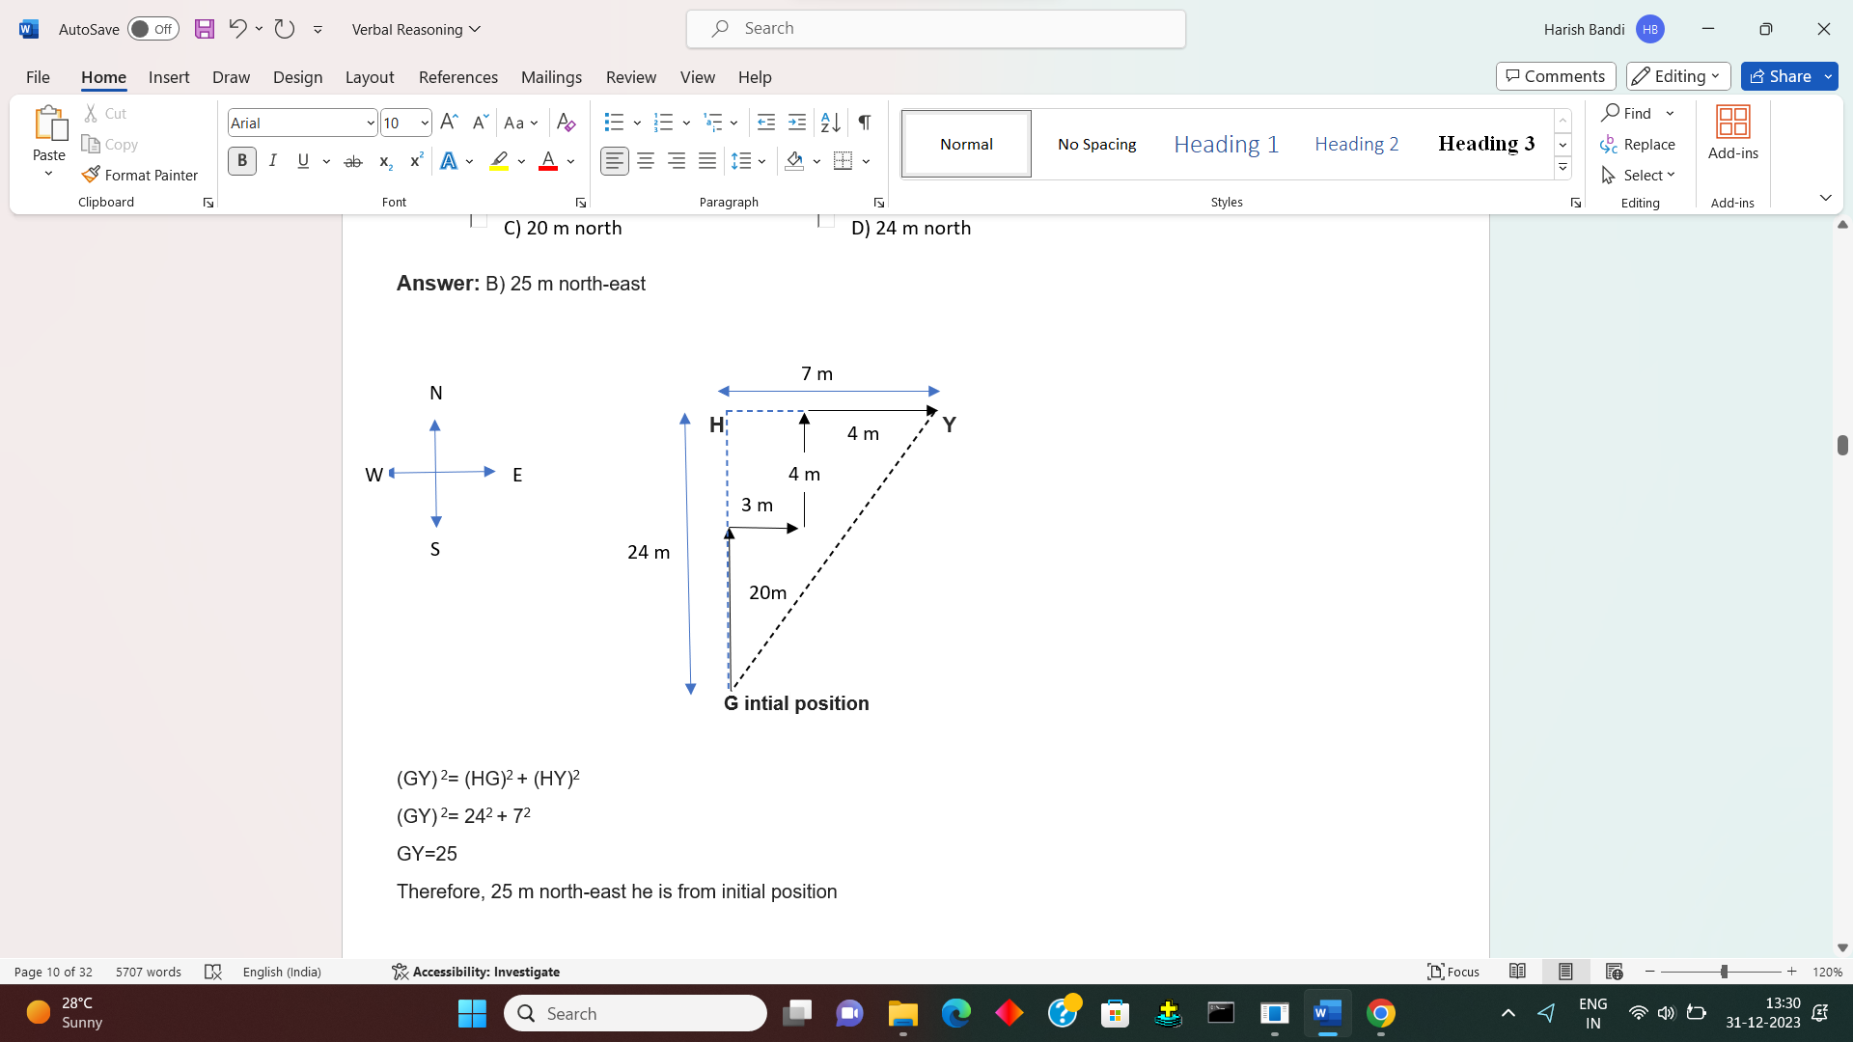

Data Sufficiency

In Data sufficiency problems, a question consists of two statements labeled I and II, in which a certain information is given. You have to decide whether the information given in the statements is sufficient to answer the question or not.

Below are the Probable answers from Data:

1. The answer can be obtained from Statement I alone but statement II alone is not sufficient to answer the question asked;
2. The answer can be obtained from statement II alone but statement I alone is not sufficient to answer the question asked;
3. The answer can be obtained from both statements I and II together; but neither statement I nor statement II alone  is sufficient to answer the question asked ;
4. We can answer  the asked question from either statement I or statement  II;
5. We can not answer the question asked  from Statement I and II together, and additional information is required to answer the question.

1.))

**Question:**In which year was Rahul born ?

**Statements:**

1. Rahul at present is 25 years younger to his mother.
2. Rahul's brother, who was born in 1964, is 35 years younger to his mother.
3. I alone is sufficient while II alone is not sufficient
4. II alone is sufficient while I alone is not sufficient
5. Either I or II is sufficient
6. Neither I nor II is sufficient
7. Both I and II are sufficient

**Answer:** Option

**Explanation: E**

From both I and II, we find that Rahul is (35 - 25) = 10 years older than his brother, who was born in 1964. So, Rahul was born in 1954.

2))

**Question:**How many children does M have ?

**Statements:**

1. H is the only daughter of X who is wife of M.
2. K and J are brothers of M.

I alone is sufficient while II alone is not sufficient

II alone is sufficient while I alone is not sufficient

Either I or II is sufficient

Neither I nor II is sufficient

Both I and II are sufficient

**Answer:** Option D)

**Explanation:**

From I, we conclude that H is the only daughter of M. But this does not indicate that M has no son. The information given in II is immaterial.

**3)) Question:**How is J related to P ?

**Statements:**

1. M is brother of P and T is sister of P.
2. P's mother is married to J's husband who has one son and two daughters.

I alone is sufficient while II alone is not sufficient

II alone is sufficient while I alone is not sufficient

Either I or II is sufficient

Neither I nor II is sufficient

Both I and II are sufficient

**Answer:** Option

**Explanation:**

From II, we know that P's mother is married to J's husband, which means that J is P's mother.

4)) **Question:**How is F related to P?

**Statements:**

1. P has two sisters M and N.
2. F's mother is sister of M's father.

I alone is sufficient while II alone is not sufficient

II alone is sufficient while I alone is not sufficient

Either I or II is sufficient

Neither I nor II is sufficient

Both I and II are sufficient

**Answer:** Option

**Explanation:**

From I and II, we conclude that P is M's brother and so M's father is P's father. So, F is the child of the sister of P's father i.e. F's mother is P's aunt or F is P's cousin.

**Question 5.**What is Monica’s position with respect to Rahul?

1. In a row of 25 students, Monica is sitting 12th from right end of row and Rahul is sitting 20th from left end of the row.
2. Monica is 4th from right end and Rahul is 8th from left end.

**Answer : (A)**

**Explanation:**

From I: The position of both of them  in a row can be known, so Monica’s position can be known.

From II: Since the total number of students is not known in this case, Monica’s position with respect to Rahul cannot be known.

Alpha-Numeric

* Alphanumeric characters are made up of the 26 letters of the alphabet (A through Z) and the digits 0 through 9. So, 1, 2, q, f, m, p, and 10 are all examples of letters and numbers. Alphanumeric characters also include characters like *, &, and @. You can also use more than one of these characters together.
* Some examples of alphanumeric characters are &AF54hh, jjHF47, and @qw99O. These characters are made up of special symbols, numbers, and letters. You can write the letters of the alphabet in lowercase or uppercase. Whether or not case sensitivity is used depends on how it is being used.
* **1A, 2B, 3C, 4D, 5E, …:** In this series, the numbers increase by 11, while the corresponding letters follow the alphabetical order. The next elements would be 6F,7G,8H6�,7�,8�, and so on.

**Q1. Based on the given arrangement which of the following groups should be next?  
BC7   R5$   6M&?**

(a)N5G  
(b)KS#   
(c)SPU   
(d)C4H   
(e) 4SP

***Answer:****c****Explanation:-*** *Given series – B @ C 7 N R % 5 $ G 6 K M & 4 S # P U 5   
So, SPU is the correct answer.*

**Q.2. W-144, ?, S-100, Q-81, O-64**

(A) U-121

(B) U-122

(C) V-122

(D) V-128

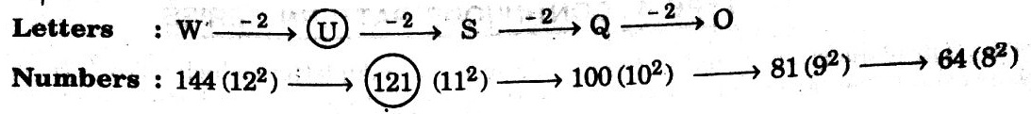

**Q.3. Q1F, S2F, U6D, W21C ?**

(A) Y44B

(B) Y66B

(C) Y88B

(D) Z88B

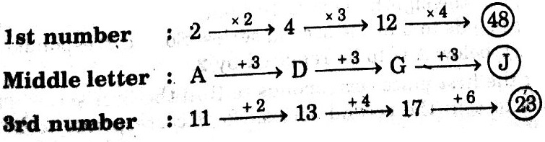

**Q 4 - Find the next term in series C4X, F9U, I16R, ....?**

[A - K25P](javascript:void(0);)

[B - L25P](javascript:void(0);)

C - L25O

[D - L27P](javascript:void(0);)

### Answer : C

### Explanation

The answer will be L25O as number increases with alphabet.

Q.5) **Analyze the below arrangement carefully and try to answer below question:**

S L 1 R % 4 J E # 7 M T 2 I 9 B H 3 A $ 9 F Q 5 D G 6 U S P

Q 4 - Suppose we reverse the order of last 15 elements, which of the following will be the fifth element to the right of 12th element from the left end?

[A - A](javascript:void(0);)

[B - E](javascript:void(0);)

C - $

[D - #](javascript:void(0);)

### Answer : C

### Explanation

The 18th element from the right end of the arrangement is 2, and the 7th element to the right of 2 is $.

### Q.6) ****If all the digits are dropped, which of the following is third to the right of the eleventh from the right end?**** ****\* E 7 O & 6 ^ 4 Z 5 * 3 9 T ! D # 2 $ U****

(a) ^   
(b) 8   
(c) Z   
(d) &   
(e) T

***Answer:****c****Explanation:-*** *Given Series – * E 7 O & 6 ^ 4 Z 5 * 3 9 T ! D # 2 $ U  
After dropping digits – * E O & ^ Z * T ! D # $ U  
So, eleventh from the right end – O  
Therefore, third to the right of O – Z*

Q.7)

4 P + S r 9 B # A 3 ? 7 c > Z % 6 d & Q @ 1

**Example 1:** If the above sequence is written in the reverse order, then which element will be 5th to the right of 16th element from the right end?

**Solution:** Reversed Sequence - 1 @ Q & d 6 % Z > c 7 ? 3 A # B 9 r S + P 4.

Hence, now the 16th element from the right end is % and 5th to the right of % is ?

Q.8) Analyze the following alphanumeric order 4 P + S r 9 B # A 3 ? 7 c > Z % 6 d & Q @ 1

If the first half of the series is written in reverse order, then which element will be fourteenth from the right end?

**Solution:** There are a total of 22 characters in the above sequence. Since, the first half of the above sequence is reversed, therefore, the sequence is:

? 3 A # B 9 r S + P 4 7 c > Z % 6 d & Q @ 1So, the required 14th character from right is '+'.

Q.9) Consider the following series: A B ! 0 C D @ 1 E F # 2 G H $ 3 I J % 4 K L ^ 5 M N & 6  
Find the second letter of 3rd pair. If we break the above series into a pair of 4 letters.

**Solution 6**: If we break above series in 3 letter pair then pairs will be as:  
A B ! 0, C D @ 1, E F # 2, G H $ 3, I J % 4, K L ^ 5, M N & 6  
Hence the second letter of 3rd pair is F.

Q.10) If all the symbols are dropped from the series, which letter/number will be eleventh to the left of fifteenth letter/number from you left ?

6 7 # U V W ? 5 @ L H 8 S A 9 T 4 $ F 3 % & G D 8 M 2 X Z W

*  2
*  V
*  6
*  Z
*  None of these

**Hide Answer**

**Ans:OPTION B**  
**11th element to the left of 15th element from the left ⇒ 4th element from the left after dropping all the Six symbols i.e. V.**

Syllogism

Syllogism is a part of logical reasoning, especially [analytical reasoning](https://testbook.com/reasoning/analytical-reasoning). It consists of some statements, and candidates need to derive conclusions from the given statements. The statements and conclusions may seem to be illogical, but while solving questions related to syllogism in reasoning, candidates must assume the given statements to be 100% true.

Sample Example:

Arrange the following statements in a logical sequence:

I. All Apples are Fruits.

II. Some Fruits are Mangoes.

III. All Mangoes are yellow Mangoes.

A) II, I, III

B) III, II, I

C) I, III, II

D) I, II, III

**Answer:**

D) I, II, III

**Explanation:**

The correct logical sequence is: All Apples are Fruits (I) → Some Fruits are Mangoes (II) → All Mangoes are Yellow Mangoes (III).

1.

**Statements:** Some actors are singers. All the singers are dancers.

**Conclusions:**

1. Some actors are dancers.
2. No singer is actor.

Only (1) conclusion follows

Only (2) conclusion follows

Either (1) or (2) follows

Neither (1) nor (2) follows

Both (1) and (2) follow

**Answer:** Option a

**Explanation:**

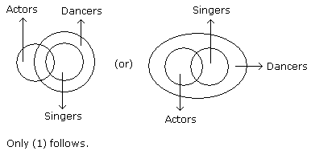

2) **Statements:** All buildings are chalks. No chalk is toffee.

**Conclusions:**

1. No building is toffee
2. All chalks are buildings.

Only (1) conclusion follows

Only (2) conclusion follows

Either (1) or (2) follows

Neither (1) nor (2) follows

Both (1) and (2) follow

**Answer:** Option a

**Explanation:**

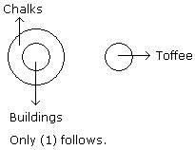

3) Statements: Some Cats are Rats. All bats are tables. All Rats are Bats.  
Conclusion:

I. Some Cats are bats

II. All bats are rats

III. All tables are cats

IV. All bats are cats

1. Only I & II follow

2. Only II follows

3. Only I & IV follow

4. None of these

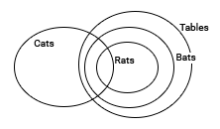

Clearly, from the diagram Conclusion I is true. So option-4

4)) Statements: Most CPUs are keyboards. No keyboard is a Mouse. All Mouses are CPU.  
Conclusion:

I. Some keyboards are CPU

II. All CPU’s are Mouse

III. No Mouse is a keyboard

IV. Some Mouse are keyboard

1. Only I follows

2. Only II and III follow

3. Only I and III follow

4. Only II follows

Answer & Explanation

**Answer Key:** 3  
**Explanation:** 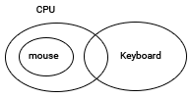 Clearly from the diagram, I and III are true.

1. 5.) Statements: Samosas are Jalebi. All Jalebis are Tikki. All Tikkis are Barfi  
   Conclusion:

I. All Jalebis are Barfi

II. All Tikkis are Samosas

III. All Samosas are Barfi

IV. All Barfi are Jalebi

1. Only I and II follow

2. Only I and III follow

3. Only II and III follow

4. All follow

Answer & Explanation

**Answer Key:** 2  
**Explanation:** 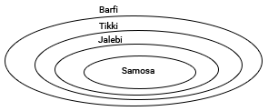 Clearly from the diagram, I and III are true.

**Q.6) Statements:** All cars are cats. All fans are cats.

**Conclusions:**

1. All cars are fans.
2. Some fans are cars.

Only (1) conclusion follows

Only (2) conclusion follows

Either (1) or (2) follows

Neither (1) nor (2) follows

Both (1) and (2) follow

**Answer:** Option

**Explanation:**

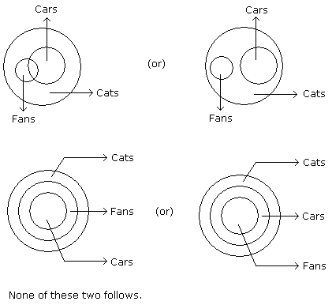

Q.7) **Statements:** Some mangoes are yellow. Some tixo are mangoes.

**Conclusions:**

1. Some mangoes are green.
2. Tixo is a yellow.

Only (1) conclusion follows

Only (2) conclusion follows

Either (1) or (2) follows

Neither (1) nor (2) follows

Both (1) and (2) follow

**Answer:** Option D

**Explanation:**

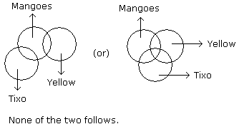

Q.8) **Statements:** All buildings are chalks. No chalk is toffee.

**Conclusions:**

1. No building is toffee
2. All chalks are buildings.

Only (1) conclusion follows

Only (2) conclusion follows

Either (1) or (2) follows

Neither (1) nor (2) follows

Both (1) and (2) follow

**Answer:** Option A

Explanation:



Q.9) Statements: Most CPUs are keyboards. No keyboard is a Mouse. All Mouses are CPU.  
Conclusion:

I. Some keyboards are CPU

II. All CPU’s are Mouse

III. No Mouse is a keyboard

IV. Some Mouse are keyboard

1. Only I follows

2. Only II and III follow

3. Only I and III follow

4. Only II follows

Answer & Explanation

**Answer Key:** 3

Clearly from the diagram, I and III are true.

Q.10) Statements: Some messages are whatsapp. All Hikes are whatsapp. All whatsapp are facebook.  
Conclusion:

I. Some facebook are messages

II. All hikes are facebook

III. Some messages are hikes

IV. Some message are facebook

1. All follow

2. Only I, II and III follow

3. Only I, II and IV follow

4. Only III and IV follow

Answer & Explanation

**Answer Key:** 3

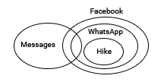Clearly from the diagram I, II and IV are true.

Statement and conclusion

Analogy

An analogy is a logical reasoning issue in which two items are compared and conclusions are reached based on their similarities and differences. Candidates will be given a question with words that are related to one another based on some logic, and they must find a word or terms that are similar to those given in the question.

Analogy Reasoning Types:

### Analogy based on letters/words:

A pair of letters or words are presented in a certain likeness between them in this form of analogy reasoning. 2.Analogy based on numbers/numerical analogy:

A pair of numbers are presented in a certain likeness between them in this type of analogy reasoning. Analogy 3.based on letters and numbers (Mixed Analogy):

A mixed pair of numbers and letters are supplied in a certain likeness between them in this type of analogy reasoning.

4.Analogy based on images:

A pair of Images are supplied in a specific likeness between them in this form of analogy reasoning

5.Analogy based on general knowledge:

A pair of words are supplied in a certain likeness between them in this form of analogy reasoning.

Country/State and Capital/Currency, Instrument and Measurement, Individual and Group, Word and Synonym/Antonym, and so on are examples of general knowledge analogies.

**Question 1:** EL : HJ :: DY : ?

**Solution:**

E(5) + 3 = H(8) and L(12) – 2 = J(10)

Similarly, D(4) + 3 = G(7) and Y(25) – 2 = W(23)

Hence, GW will replace the question mark

**Question 2:** RJ : IQ :: DH : ?

**Solution**:

R – I (Reverse Letter of R is I) and J – Q (Reverse Letter of J is Q)

Similarly, D – W (Reverse letter of D is W) and H – S (Reverse letter of H is S)

Hence, WS will replace the question mark.

**Question 8:**Afghanistan : Kabul :: USA : ?

**Solution:**

Kabul is the capital of Afghanistan.

Similarly, Washington is the capital of the USA.

Hence, Washington will replace the question mark.

**Question 9:**Abode : Dwelling :: Blend : ?

**Solution:**

Abode is the synonym of Dwelling.

Similarly, Mix is the synonym of Blend.

Hence, Mix will replace the answer.

**Question 10:**History : Herodotus ∷ ? : Eratosthenes

**Solution:**

Here the relation is:

History : Herodotus → Herodotus is the father of History.

Similarly, ? : Eratosthenes → Eratosthenes is the father of Geography.

Hence, ‘Geography’ is the correct answer.

**Question 11:** Author : Book :: Painter : ?

**Solution:** Canvas (The relationship is the creator and their creation: an author creates a book and a painter creates a painting on a canvas.)

**Question 12:** Nurse : Hospital :: Teacher : ?

**Solution:** School (The relationship is the professional and their workplace: a nurse works in a hospital and a teacher works in a school.)

**Question 13:** Odometer : Distance :: Thermometer : ?

**Solution:** Temperature (The relationship is the instrument and the quantity it measures: an odometer measures distance and a thermometer measures temperature.)

**Question 14:** Oak : Tree :: Rose : ?

**Solution:** Flower (The relationship is the specific to the general category: oak is a type of tree and rose is a type of flower.)

**Question 15:** Starve : Food :: Dehydrate : ?

**Solution:** Water (The relationship is the condition caused by a lack of a particular substance: starve is caused by a lack of food, and dehydrate is caused by a lack of water.)

**Question 16:** Marathon : Race :: Sonnet : ?

**Solution:** Poem (The relationship is the specific to the general category: a marathon is a type of race and a sonnet is a type of poem.)

**Question 17:** Fear : Phobia :: Love : ?

**Solution:** Philia (The relationship is the emotion and its corresponding scientific term: fear is called phobia and love is called philia.)

**Question 18:** Encyclopedia : Knowledge :: Thesaurus : ?

**Solution:** Synonyms (The relationship is the reference book and the information it provides: an encyclopedia provides knowledge and a thesaurus provides synonyms.)

**Question 19:** Butterfly : Caterpillar :: Frog : ?

**Solution:** Tadpole (The relationship is the adult and the juvenile form of an organism: a butterfly develops from a caterpillar and a frog develops from a tadpole.)

**Question 20:** Earth : Planet :: Sun : ?

**Solution:** Star (The relationship is the specific to the general category: Earth is a type of planet and Sun is a type of star.)

**Question 21:** Glacier : Ice :: Desert : ?

**Solution:** Sand (The relationship is the geographical feature and its predominant substance: a glacier is made of ice and a desert is made of sand.)

**Question 22:** Square : Rectangle :: Circle : ?

**Solution:** Ellipse (The relationship is the specific to the general geometric shape: a square is a type of rectangle and a circle is a type of ellipse.)

**Question 23:** Conductor : Orchestra :: Captain : ?

**Solution:** Ship (The relationship is the leader and the entity they lead: a conductor leads an orchestra and a captain leads a ship.)

**Question 24:** Ignite : Fire :: Freeze : ?

**Solution:** Ice (The relationship is the action and the resulting state: ignite leads to fire and freeze leads to ice.)

Statement and conclusion

Statement and Conclusion reasoning is a very important section of Analytical Reasoning, where passage or statements will be given followed by some conclusions. Candidates need to take decisions based on these statements and select the correct conclusion from the given ones.

**Example 2**: Statement: The travel organizer has canceled the mountain trip.  
Conclusion 1: Trip wasn’t cost-effective for the travel organizer.  
Conclusion 2: Bad weather conditions lead to the cancellation of this trip.  
Choose the correct option from below:

1. Only Conclusion I follows
2. Only Conclusion II follows
3. Neither Conclusion I nor Assumption II follows
4. Either Conclusion I or Assumption II follows
5. Both Conclusion I and Assumption II follow

**Solution 2**: As per the statement, both the Conclusion are logically correct as there’s not much clarity in a statement for reason. In absence of reason, both the conclusions can be the reason for the mountain trip cancellation.

Hence, 5th option is correct.

**Q.1) Statements:**Government has spoiled many top ranking financial institutions by appointing bureaucrats as Directors of these institutions.

**Conclusions:**

1. Government should appoint Directors of the financial institutes taking into consideration the expertise of the person in the area of finance.
2. The Director of the financial institute should have expertise commensurate with the financial work carried out by the institute.

Only conclusion I follows

Only conclusion II follows

Either I or II follows

Neither I nor II follows

Both I and II follow

**Answer:** Option e

**Explanation:**

According to the statement, Government has spoiled financial institutions by appointing bureaucrats as Directors. This means that only those persons should be appointed as Directors who are experts in finance and are acquainted with the financial work of the institute. So, both I and II follow.

**Q.2) Statements:**Population increase coupled with depleting resources is going to be the scenario of many developing countries in days to come.

**Conclusions:**

1. The population of developing countries will not continue to increase in future.
2. It will be very difficult for the governments of developing countries to provide its people decent quality of life.

Only conclusion I follows

Only conclusion II follows

Either I or II follows

Neither I nor II follows

Both I and II follow

**Answer:** Option B

**Explanation:**

The fact given in I is quite contrary to the given statement. So, I does not follow. II mentions the direct implications of the state discussed in the statement. Thus, II follows.

Q.3) **Statements:**The distance of 900 km by road between Bombay and Jafra will be reduced to 280 km by sea. This will lead to a saving of Rs. 7.92 crores per annum on fuel.

**Conclusions:**

1. Transportation by sea is cheaper than that by road.
2. Fuel must be saved to the greatest extent

Only conclusion I follows

Only conclusion II follows

Either I or II follows

Neither I nor II follows

Both I and II follow

**Answer:** Option B

**Explanation:**

According to the statement, sea transport is cheaper than road transport in the case of route from Bombay to Jafra, not in all the cases. So, conclusion I does not follow. The statement stresses on the saving of fuel. So, conclusion II follows.

Q.4) **Statements:**The manager humiliated Sachin in the presence of his colleagues.

**Conclusions:**

1. The manager did not like Sachin.
2. Sachin was not popular with his colleagues.

Only conclusion I follows

Only conclusion II follows

Either I or II follows

Neither I nor II follows

Both I and II follow

**Answer:** Option D

**Explanation:**

The manager might have humiliated Sachin not because of his dislike but on account of certain negligence or mistake on his part. So, I does not follow. Also, nothing about Sachin's rapport with his colleagues can be deduced from the statement. So, II also does not follow.

Q.5) **Statements:**National Aluminium Company has moved India from a position of shortage to self-sufficiency in the metal.

**Conclusions:**

1. Previously, India had to import aluminium.
2. With this speed, it can soon become a foreign exchange earner.

Only conclusion I follows

Only conclusion II follows

Either I or II follows

Neither I nor II follows

Both I and II follow

**Answer:** Option E

**Explanation:**

According to the statement, National Aluminium Company has moved India from a position of shortage in the past to self-sufficiency in the present. This means that previously, India had to import aluminium. So, I follows. Also, it can be deduced that if production increases at the same rate, India can export it in future. So, II also follows.

Q.6) **Statements:**All those political prisoners were released on bail who had gone to jail for reasons other than political dharnas. Bail was not granted to persons involved in murders.

**Conclusions:**

1. No political - prisoner had committed murder.
2. Some politicians were not arrested.

Only conclusion I follows

Only conclusion II follows

Either I or II follows

Neither I nor II follows

Both I and II follow

**Answer:** Option A

**Explanation:**

According to the statement, the political prisoners can be divided into two groups - those who were released and those who were put in jail for political dharnas. However, no person involved in murder was released. This means that no political prisoner had committed murder. So, I follows. Clearly, II is not directly related to the statement and does not follow.

Q.7) Statement : Modern man influences his destiny by the choice he makes unlike in the past.Conclusions:I. Earlier there were fewer options available to man.II. There was no desire in the past to influence the destiny.

 Only conclusion I follows

 Only conclusion II follows

 Either I or II follows

 Neither I nor II follows

**Correct Ans:**Only conclusion I follows

**Explanation:**

I directly follows from the statement while II cannot be deduced from it.

Q.8) **Statements:**The best way to escape from a problem is to solve it.

**Conclusions:**

1. Your life will be dull if you don't face a problem.
2. To escape from problems, you should always have some solutions with you.

Only conclusion I follows

Only conclusion II follows

Either I or II follows

Neither I nor II follows

Both I and II follow

**Answer:** Option D

**Explanation:**

Clearly, both I and II do not follow from the given statement.

Q.9) **Statements:**It is almost impossible to survive and prosper in this world without sacrificing ethics and morality.

**Conclusions:**

1. World appreciates some concepts but may not uphold it.
2. Concept of ethics and morality are not practicable in life.

Only conclusion I follows

Only conclusion II follows

Either I or II follows

Neither I nor II follows

Both I and II follow

**Answer:** Option B

**Explanation:**

Clearly, I is vague and so does not follow. However, II directly follows from the given statement.

Q.10) **Statements:**A large majority of the work force in India is unorganised. Most of them earn either the minimum or uncertain wages while others are engaged in sundry jobs.

**Conclusions:**

1. The workers in the organised sector get better facilities and stay longer in their jobs.
2. Some workers in the unorganised sector of the work force have a regular and fixed income.

Only conclusion I follows

Only conclusion II follows

Either I or II follows

Neither I nor II follows

Both I and II follow

**Answer:** Option B

**Explanation:**

The workers in the organised sector are not being talked about in the statement. So, I does not follow. It is mentioned that some workers in the unorganised sector are engaged in sundry jobs. This means that they have fixed income. So, II follows.

Seating-Arrangement

Seating Arrangement is a process of making a group of people sit as per a prefixed manner. The seating arrangement reasoning questions are based on a set of information including a certain set of conditions. Information of the [arrangement of the people](https://testbook.com/reasoning/arrangement-pattern-reasoning) in a row or around the circle will be given, and candidates need to arrange people in the row or circle or square according to the given condition.

## Types of Seating Arrangement

As now we know what consists of the questions related to the Seating Arrangement reasoning section. Let us see the various types of seating arrangement questions in reasoning that may come in competitive exams.

### 1. Linear Seating Arrangement

In this type of [linear seating arrangement reasoning](https://testbook.com/reasoning/linear-arrangement-reasoning), candidates are required to arrange people in a row or multiple rows according to the given conditions. Candidates need to identify the exact position of the objects and their positions with respect to one another based on the information given in the seating arrangement questions.

### 2. Circular Seating Arrangement

In this type of [circular seating arrangement reasoning](https://testbook.com/reasoning/circular-arrangement-reasoning) questions, people will be seated around a circular table.

Q.1) In row of boys, sid is 8th from left and virat is 13th from right. If they interchange sid becomes 23rd from left.How many boys are there?

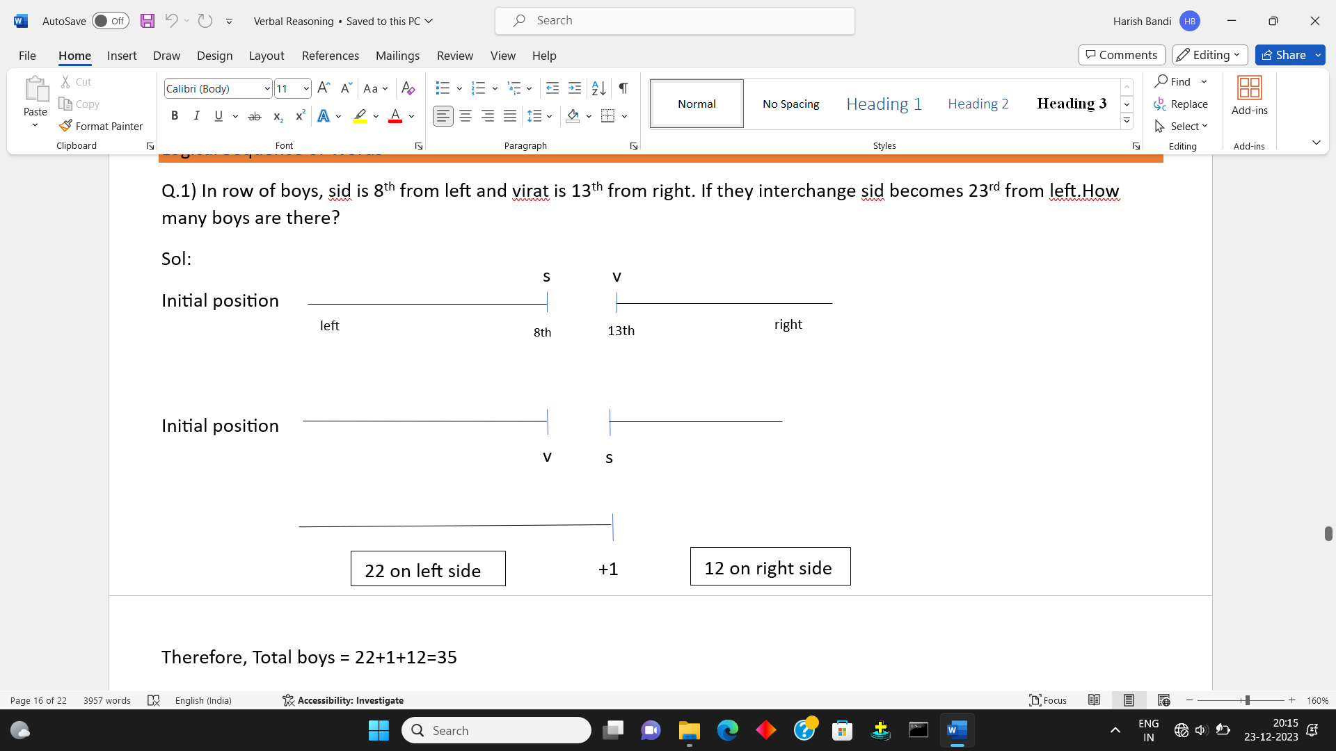

Therefore, Total boys = 22+1+12=35

Q.2) A, P, R, X, S and Z are sitting in a row. S and Z are in the centre. A and P are at the ends. R is sitting to the left of A. Who is to the right of P ?

Sol:

S and Z are in centre _ _ S Z _ _

A and P are at the ends P _ S Z _ A

R is sitting to the left of A P _ S Z R A

Therefore, Right of P is ‘X’

Q.3) A, B, C, D & E are sitting on a bench. A is sitting next to B, C is sitting next to D, D is not sitting with E who is on the left end of the bench. C is on the second position from the right. A is to the right of B & E. A and C are sitting together. In which position A is sitting

Sol:

A is sitting next to B B A _ _ _

C is sitting next to D B A D C _

D is not sitting with E who is on the left end of the bench E B A D C

C is on the second position from the right E B A C E

Therefore, A is sitting in between B and C.

Q.4) A, B, C, D, E, F and G are 7 friends sitting in a single row facing North.  
D is to the immediate right of C, E and A are neighbours of F, B is to the immediate left of C and on second place from left most end, A is at the right most end. **Who is in between C and E?**

Sol:

D is to the immediate right of C C D _ _ _ _ _

E and A are neighbours of F C D E F A_ _

B is to the immediate left of C and on second place from left most end _ B C D E F A

A is at the right most end G B C D E F A

Therefore, D is in between C and E.

1. P, Q, R, S, T, U and V are sitting around a circular table facing the centre
2. R is next to the left of U and V is second to the left of R.
3. P is sitting third to the left of T.
4. Q is between S and T.

**Q.5.**Which of the following is false?

1. P is fourth to the right of T.

2. U is to the immediate right of R.

3. U is third to the right of S.

4. Q is to the immediate left of S.

Answer & Explanation

**Sol : Option** 3  
We can arrange the persons in the following way.  
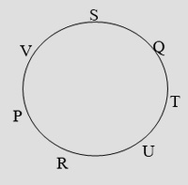  
U is third to the right of S is wrong.

Logical Sequence of Words

Logical sequence of Words' is basically the arrangement of words according to a certain order which can be their size, occurrence, dictionary order etc.

In these types of questions, four/five/six words are given and the candidate is required to arrange the given words either in a logical sequence or in an order according to dictionary.

## **Types of Questions**

## **Type 1 : Arrange According to Logic**

As the name implies, in this type of questions, a sequence is formed with a certain number of words given in such a way that it gives a logical step-by-step completion of the process or the activity described.

## **Type 2 : Arrangement According to Dictionary**

Arranging words in alphabetical order implies 'to arrange them in the order as they appear in a dictionary'. For this arrangement, first we shall take the first letter of each word and then arrange the words in the order in which they appear in the English alphabet, then take the second letter and so on.

Q.1) Arrange the words given below in a meaningful sequence.

|  |  |  |
| --- | --- | --- |
| 1. Leaf | 2. Fruit | 3. Stem |
| 4. Root | 5. Flower |  |

3, 4, 5, 1, 2

4, 3, 1, 5, 2

4, 1, 3, 5, 2

4, 3, 1, 2, 5

**Answer:** Option

**Explanation:**

The correct order is :

|  |  |  |  |  |
| --- | --- | --- | --- | --- |
| Root | Stem | Leaf | Flower | Fruit |
| 4 | 3 | 1 | 5 | 2 |
|  |  |  |  |  |

Q.2) Arrange the words given below in a meaningful sequence.

|  |  |  |
| --- | --- | --- |
| 1. Infant | 2. Old | 3. Adult |
| 4. Adolescent | 5. Child |  |

5, 4, 3, 2, 1

3, 4, 2, 1, 5

2, 3, 4, 5, 1

1, 5, 4, 3, 2

**Answer:** Option

**Explanation:**

The correct order is :

|  |  |  |  |  |
| --- | --- | --- | --- | --- |
| Infant | Child | Adolescent | Adult | Old |
| 1 | 5 | 4 | 3 | 2 |

Q.3) Arrange the words given below in a meaningful sequence.

|  |  |  |
| --- | --- | --- |
| 1. Income | 2. Status | 3. Education |
| 4. Well-being | 5. Job |  |

3, 1, 5, 2, 4

1, 3, 2, 5, 4

1, 2, 5, 3, 4

3, 5, 1, 2, 4

**Answer:** Option

**Explanation:**

The correct order is :

|  |  |  |  |  |
| --- | --- | --- | --- | --- |
| Education | Job | Income | Status | Well-being |
| 3 | 5 | 1 | 2 | 4 |

Q.4) Arrange the words given below in a meaningful sequence.

1.Presentation  2.Recommendation  3. Arrival  4.Discussion  5.Introduction

|  |  |
| --- | --- |
| A) 5, 3, 4, 1, 2 | B) 3, 5, 4, 2, 1 |
| C) 3, 5, 1, 4, 2 | D) 5, 3, 1, 2, 4 |

[Answer & Explanation](javascript:showans('5351','Logical%20Sequence%20of%20Words'))**Answer:** C) 3, 5, 1, 4, 2  
  
**Explanation:**

The correct order is :

Arrival   Introduction   Presentation   Discussion  Recommendation

      3                    5                        1                    4                       2

Q.5) Arrange the words given below in a meaningful sequence.

1. Poverty   2. Population   3. Death    4. Unemployment    5. Disease

|  |  |
| --- | --- |
| A) 2, 3, 4, 5, 1 | B) 3, 4, 2, 5, 1 |
| C) 2, 4, 1, 5, 3 | D) 1, 2, 3, 4, 5 |

[Answer & Explanation](javascript:showans('5348','Logical%20Sequence%20of%20Words'))**Answer:** C) 2, 4, 1, 5, 3  
  
**Explanation:** The correct order is :

Population    Unemployment    Poverty     Disease   Death

          2                   4                             1                    5           3

Q.6) Arrange the words given below in a meaningful sequence.

1. Poverty   2. Population   3. Death    4. Unemployment    5. Disease

|  |  |
| --- | --- |
| A) 2, 3, 4, 5, 1 | B) 3, 4, 2, 5, 1 |
| sC) 2, 4, 1, 5, 3 | D) 1, 2, 3, 4, 5 |

[Answer & Explanation](javascript:showans('5348','Logical%20Sequence%20of%20Words'))**Answer:** C) 2, 4, 1, 5, 3  
  
**Explanation:**

The correct order is :

Population    Unemployment    Poverty     Disease   Death

          2                   4                             1                    5           3

Q.7) Arrange the words given below in a meaningful sequence.

1.Caste  2. Family  3. Newly married Couple  4.Clan  5.Species

|  |  |
| --- | --- |
| A) 2, 3, 1, 4, 5 | B) 3, 4, 5, 1, 2 |
| C) 3, 2, 1, 4, 5 | D) 4, 5, 3, 2, 1 |

[Answer & Explanation](javascript:showans('5349','Logical%20Sequence%20of%20Words'))**Answer:** C) 3, 2, 1, 4, 5  
  
**Explanation:**

The correct order is :

Newly married Couple     Family    Caste    Clan    Species

                      3                        2                1             4             5

Q.8) Arrange the words given below in a meaningful sequence.

1.Elephant  2.Cat  3.Mosquito  4.Tiger    5. Whale

|  |  |
| --- | --- |
| A) 5, 3, 1, 2, 4 | B) 3, 2, 4, 1, 5 |
| C) 1, 3, 5, 4, 2 | D) 2, 5, 1, 4, 3 |

[Answer & Explanation](javascript:showans('5350','Logical%20Sequence%20of%20Words'))**Answer:** B) 3, 2, 4, 1, 5  
  
**Explanation:**

The correct order is :

Mosquito    Cat    Tiger   Elephant   Whale

         3             2          4              1             5

Q.9) **Example 4:**Arrange the given words in a logical and meaningful order.

1. Travel  2. Destination 3. Payment 4. Berth/Seat number 5. Reservation 6. Availability of Berth/Seat for reservation

(a) 6, 2, 5, 4, 3, 1   (b) 5, 3, 4, 6, 1, 2

(c) 2, 6, 3, 5, 4, 1   (d) 1, 2, 5, 4, 3, 6

**Solution:** (c) From the given words, it is clear that in order to perform a journey, first, a destination is to be identified, secondly availability of berth/seat is ascertained, followed by payment for reservation. As a result, berth is allotted and traveling is completed.

Q.10) **Example 2:**If the following five words are arranged in alphabetical order, then which word will come in the middle ?

(a) Electric       (b)Elector

(c) Electrode   (d)Elect

(e) Electron

**Solution:** (a) Arranging the words in alphabetical order we have  
Elect, Elector, Electric, Electrode, Electron.  
Hence, Electric will come in middle.